IV. Safety in the lab
- Preparing for the lab
- Be prepared in order to stay safe when doing science activities in the lab.
- Read the procedure and make sure you understand the directions
- Ask the teacher if you don’t understand
- Performing the lab
- When doing the lab, safety is most important.
- Follow all teacher and book directions exactly
- Do not fix anything yourself. Ask for help.
- Keep work area clean and organized
- End of Lab Procedures
- Clean up work area at end of lab.
- Turn off and unplug equipment
- Return items to proper locations
- Dispose of waste properly
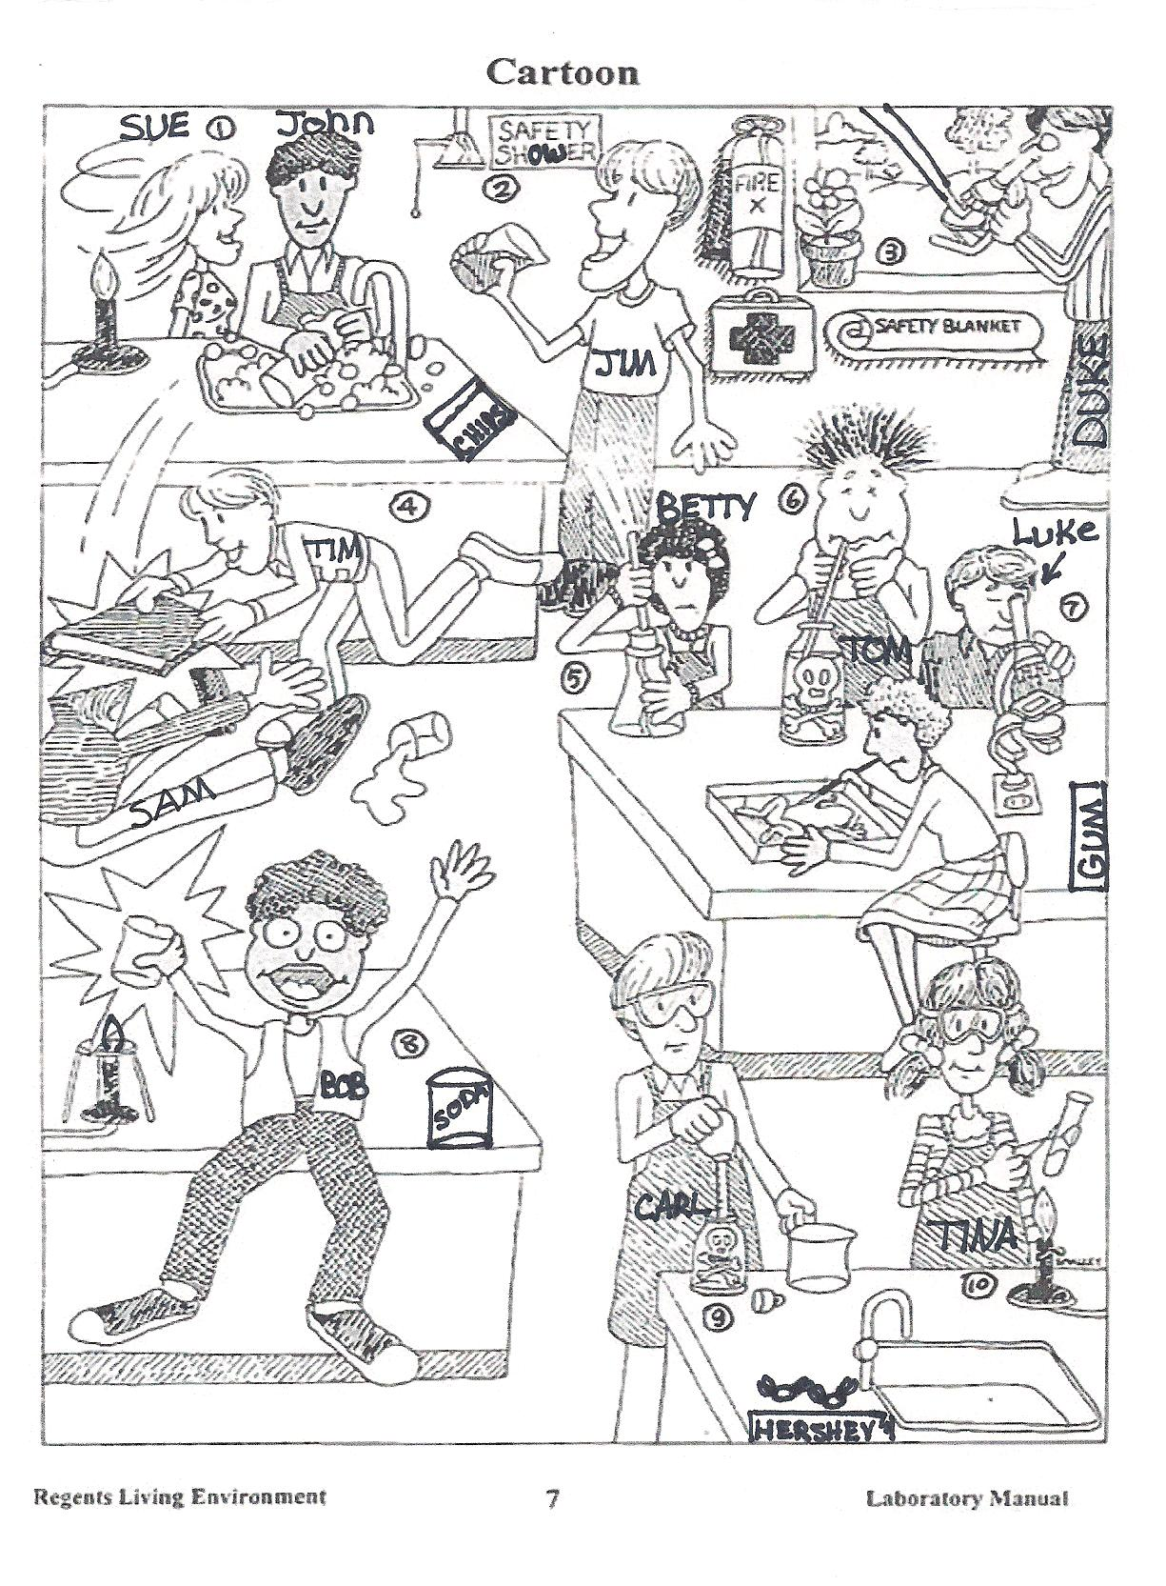

- List 3 unsafe activities shown in the illustration and explain why each is unsafe.
- List 2 correct lab procedures depicted in the illustration.
- What is Bob doing wrong and what should have Bob done?
- What should Bob do after the accident?
- What should Sue have done to avoid an accident?
- Compare Luke and Duke’s lab techniques. Who is following the rules?
- What are three things shown in the lab that should not be there?
- Compare Tom and Carl’s lab techniques. Who is doing it the correct way?
- List four items in the illustration that are in the classroom for the safety of the students in the lab.
- List three things Tina is doing correct while performing the lab.

